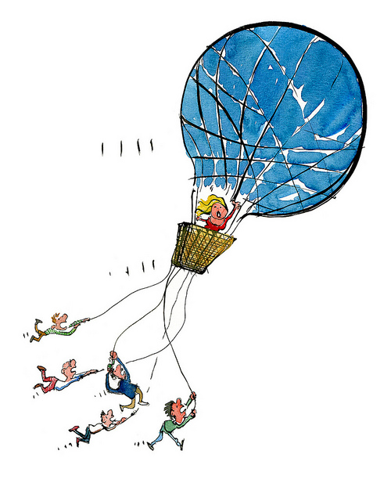 | The Gases  How High Can You Go? | Name ______________________________  Date _______________________________
 | Essential Questions  - How do gases make our daily lives better? | Objectives  - Determine which variables are at play, which variable(s) is constant.  - Determine the relationship between the variables.  - Determine what a plot of the two variables would look like.
Vocabulary
pressure, volume, temperature, Kelvin (K), kinetic molecular theory (KMT), compression, expansion

For gases volume, temperature, pressure, and moles have the greatest effect on the nature of a gas. For each of the following activities we will assume that the number of moles remains constant, unless specifically stated. Complete each station according to the directions and record the following:
Activity 1:
- Turn on hot plate to approximately 5.
- Insert the pressure probe into the stopper and insert the stopper into the Erlenmeyer flask.
- Record the initial pressure.
- Place the stoppered Erlenmeyer onto the hot plate and watch the reading.
- Once a change has been seen remove the Erlenmeyer from the hot plate and continue to monitor the readings.
- Record observations.

What two variables are compared? | What variable remains constant?
Observations:
Mathematical Relationship: | Graph:

Activity 2:
- Mass an empty balloon on the balance – record the mass.
- Mass the blown up balloon on the balance – record the mass.
- Account for any differences seen.

What variable is being measured? | What variable(s) remains constant?
Observations/Explanation:

Activity 3:
- Record any initial observations.
- Depress the syringe - record any observations.
- Pull out the plunger (do NOT remove it from the barrel) – record any observations.
- Repeat.

What two variables are compared? | What variable remains constant?
Observations:
Mathematical Relationship: | Graph:

Activity 4:

- Record any initial observations.
- Holding the bottle over the sink open the cap – record any observations.
- Close the cap – record any observations.
- Repeat.

What variable is being studied? | What variable(s) remains constant?
Observations/Explanation:

Activity 5:
- Record any initial observations.
- Place the sealed syringe into the water on the hot plate and wait approximately 2 minutes – record any observations.
- Remove the syringe and then quickly place it into the ice bath – record any observations.

What two variables are compared? | What variable remains constant?
Observations:
Mathematical Relationship: | Graph:

Activity 6:
- Record any initial observations.
- Gently squeeze the center of the bottle – record any observations.
- Release the bottle – record any observations.
- Repeat.

What two variables are compared? | What variable remains constant?
Observations:
Mathematical Relationship: | Graph:

Activity 7:
- Record any initial observations
- Ensure that the candle is standing upright in a shallow dish of water.
- Light the candle.
- In one fluid motion, be sure not to touch the sides of the graduated cylinder to the candle, invert the graduated cylinder over the candle until it is touching the bottom of the dish. If the candle goes out while inverting the cylinder, relight the candle – record any observations.

What two variables are compared? | What variable remains constant?
Observations:
Mathematical Relationship: | Graph:

Activity 8:
- Record any initial observations.
- Open and spread out 4 pieces of newspaper on the table. Smooth the paper out as flat as possible.
- Insert the paint stirrer, handle side in, under the layers of paper until approximately 4 inches of the wood is exposed.
- Do not hold onto the wood under the paper – record any observations.
- One member of the group, attempt to break the wood by forcefully hitting it with a downward motion with your fist – record any observation.

What variable is being studied? | What variable(s) remain(s) constant?
Observations/Explanation:
Activity 9:
- Record any initial observations.
- Add water to a soda can until the bottom of the can is just barely covered with water.
- Place the can onto the heated hot plate and let boil. DO NOT let it boil dry. You will know it is boiling because a crackling sound will be heard.
- Once boiling, using the tongs, quickly, with ninja like speed, invert the soda can into the tray of cold water – record any observations.

What variables are compared? | What variable(s) remain(s) constant?
Observations:
Mathematical Relationship: | Graph:

